**Operators in Javascript**

**Javascript operators are used to perform different types of mathematical and logical computations.**

1. **Arithmetic Operators**
2. **Assignment Operators**
3. **Comparison Operators**
4. **Logical Operators**
5. **String Concatenation Operator**
6. **Arithmetic Operators:** Addition (+), Subtraction (-), Multiplication (*), Division (/), Modulus (%), Increment (++), Decrement (--)

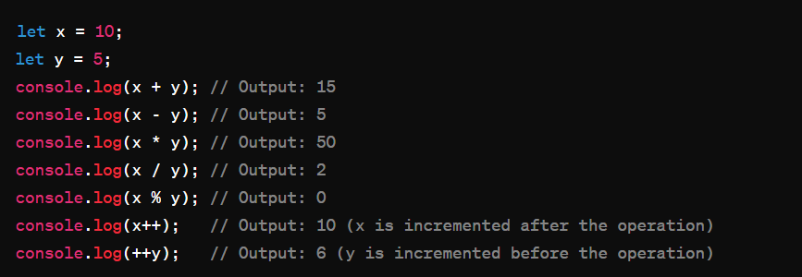

1. **Assignment Operators:** Assigns a value to a variable. It can also perform arithmetic operations with assignment.

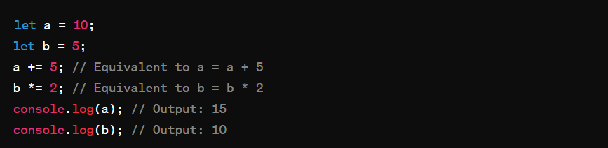

1. **Comparison Operators:** Compare two values and return a Boolean result (true or false).

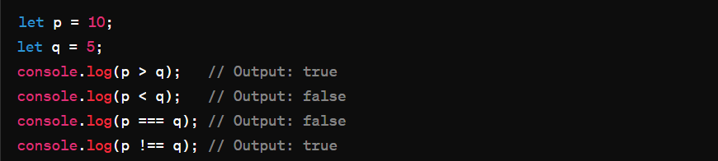

1. **Logical Operators:** Used to combine conditional statements. (AND: &&, OR: ||, NOT: !).

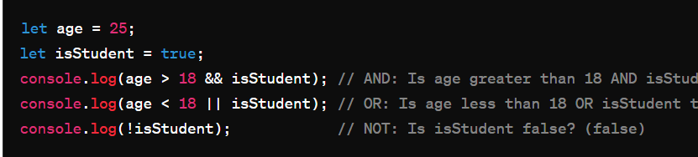

1. **String Concatenation Operator:** Used to concatenate two or more strings.

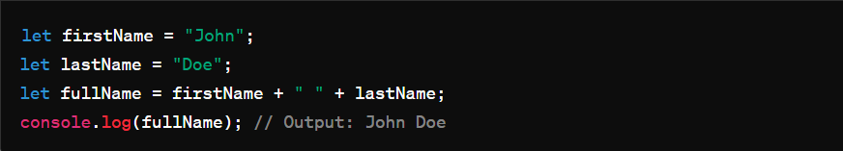

**How to know the type of operands:**

You can use the typeof operator to find the data type of a JavaScript variable.

In JavaScript, the **typeof** operator is used to determine the type of a variable or an expression. It returns a string indicating the type of the operand.

